Chem 261 Sep 9, 2020

**Size and Shape of Molecules: determined by bond lengths and bonding type**

NOTE THE FOLLOWING (Estimated bond length between atoms)

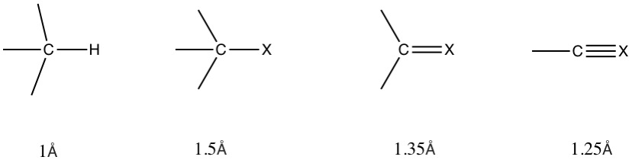

X = C, O, N, F

**Representation of Molecules**

* Show only electrons in outer (valence) shell
* Non-bonding electrons (lone pairs) may or may not be shown
* Use element symbols, but carbon can be represented by point of angle or end of line
* Hydrogens and bonds to them from carbon are optional; show others.
* Each line in a structure represents 2 e-
* Solid wedge (): Toward you / out of the page
* Dashed wedge (): Away from you / into the page

**Examples:**

**Propene:**



1. Tetrahydrofuran (THF)



NB: Oxygen in the stable uncharged state forms two bonds with 2 lone pairs of electrons

NB: Nitrogen in the stable uncharged state forms three bonds with 1 lone pair of electrons



1. **Conine (Poison Hemlock)**

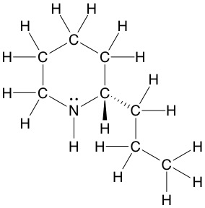

Chemical Formula: C8H17N

Molecular Weight: 127.23

1. **Testosterone (a steroid) - C19**

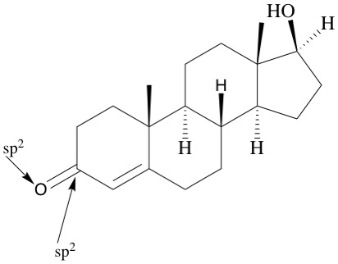 



CH3 = Methyl

CH2 = Methylene

CH = Methine

Functional groups in testosterone (alkene and ketone and alcohol)

1. **Estradiol - C18**

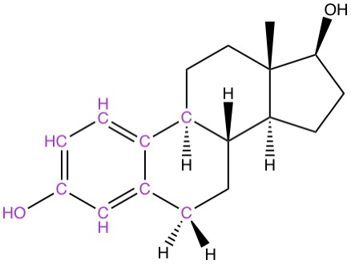

Female hormone

All purple atoms are in the same plane