CHEM 261 September 13, 2018

**AS A REMINDER:**

**Formal Charge**

* Convention to keep track of charges
* ∑ (sum of) of formal charges on all atoms in a molecule = overall charge on molecule

**Rules for calculating formal charge**

* Add number of protons in nucleus
* Subtract number of inner shell electrons
* Subtract number of unshared electrons
* Subtract ½ of the number of shared outer shell electrons

**Examples:**

1. **Nitrite anion**

Single bonded oxygen:

+8 (number of protons)

-2 (1s electrons)

-6 (unshared electrons)

½ x 2 = -1 (1/2 of shared electrons)

**-1**

Formal charge



Overall charge on the nitrite anion is = **-1**

1. **Methyl anion**

Formal Charge on Carbon

+6 (number of protons)

-2 (1s electrons)

-2 (unshared electrons)

½ x 6 = -3 (1/2 of shared electrons)

**-1**



Overall charge on the methyl anion is = **-1**

1. **Methyl radical**

Formal Charge on Carbon

+6 (number of protons)

-2 (1s electrons)

1 (unshared electrons)

½ x 6 = -3 (1/2 of shared electrons)

**0**



Overall charge on the methyl anion is = **0**

1. **Methyl cation**

Formal Charge on Carbon

+6 (number of protons)

-2 (1s electrons)

0 (unshared electrons)

½ x 6 = -3 (1/2 of shared electrons)

**+1**

* (sp2 hybridized carbon, planer shape**)**
* can be reactive intermediate in principle

Overall charge on the methyl anion is = **+1**

** **

**DRAWING CHEMICAL STRUCTURES**

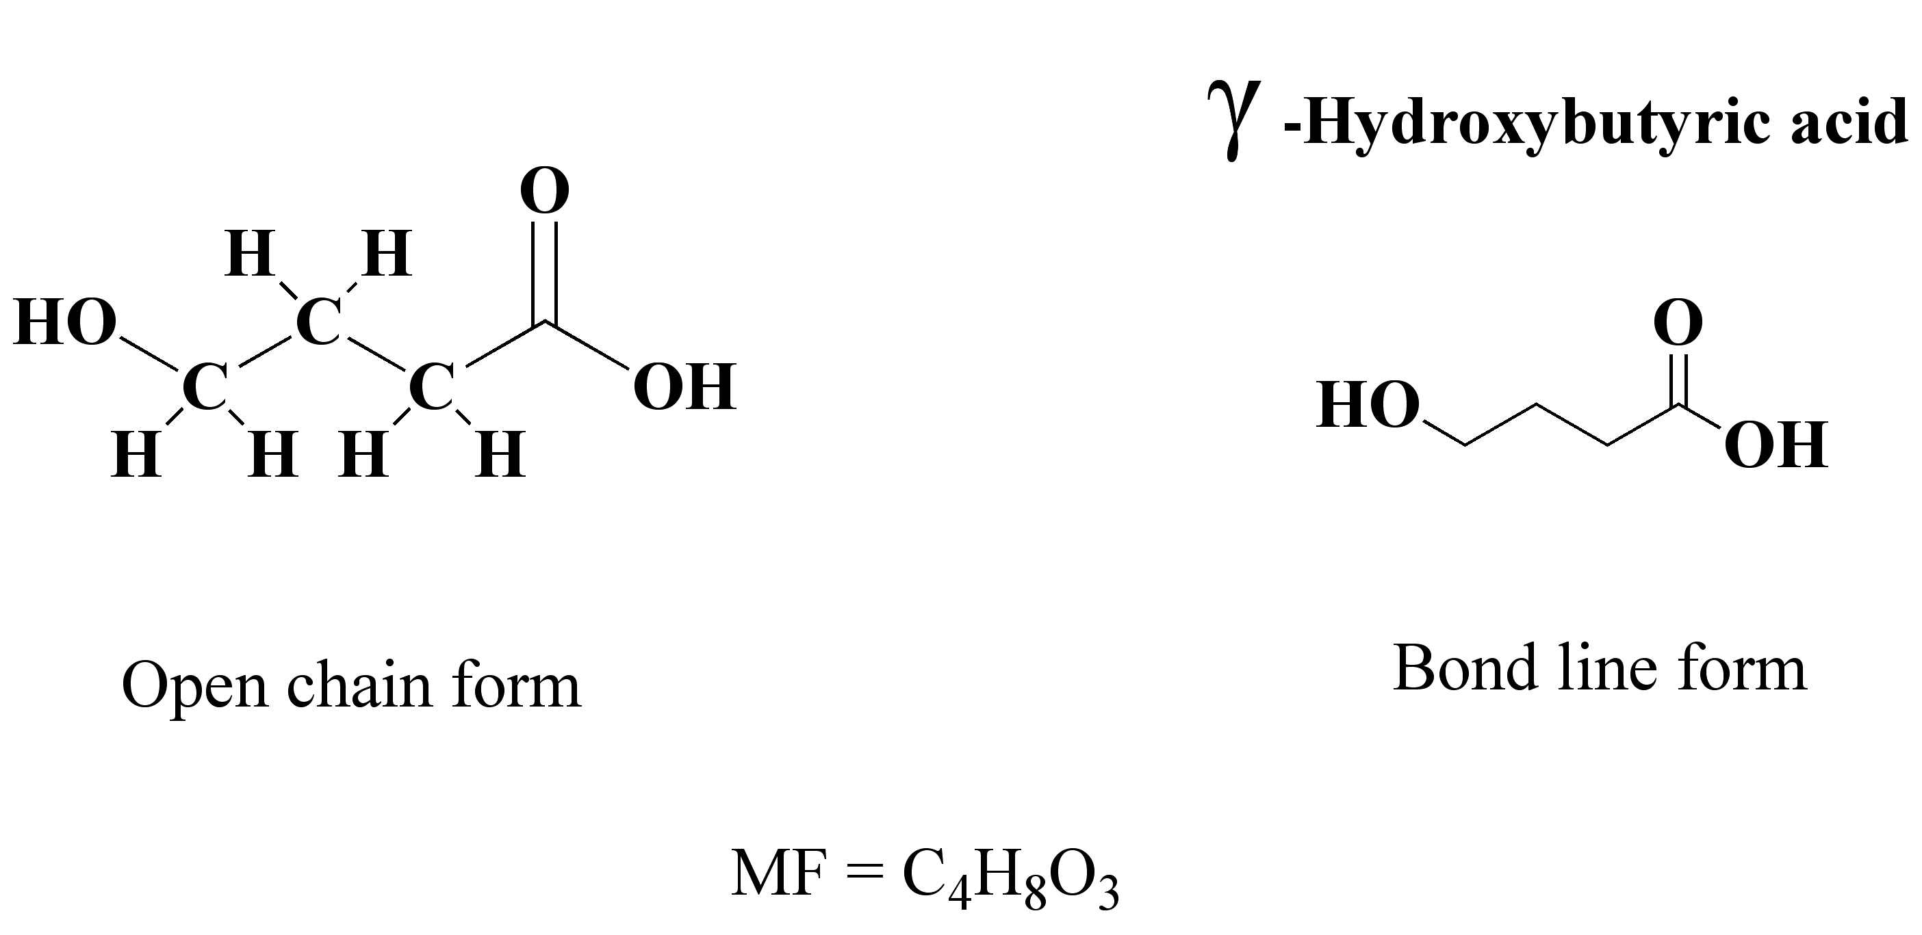

**NB:The above compound can also be represented in the following forms, resulting from the free rotation of single bonds (sigma).**

