CHEM 261 October 07, 2020

**Stereochemistry and Chirality**

*Chiral* object or molecule: has a non-superimposable mirror image

*Achiral* object: not chiral, has a superimposable mirror image

*Resolution* - Separation of right and left-handed forms (enantiomers)

*Enantiomers*: molecules that are stereoisomers and are non-superimposable mirror images of each other. Physical properties of enantiomers are the same, as far as they are measured in an achiral environment. A chiral agent of molecule is necessary to distinguish them.

*Diastereomers*: stereoisomers that are not enantiomers.

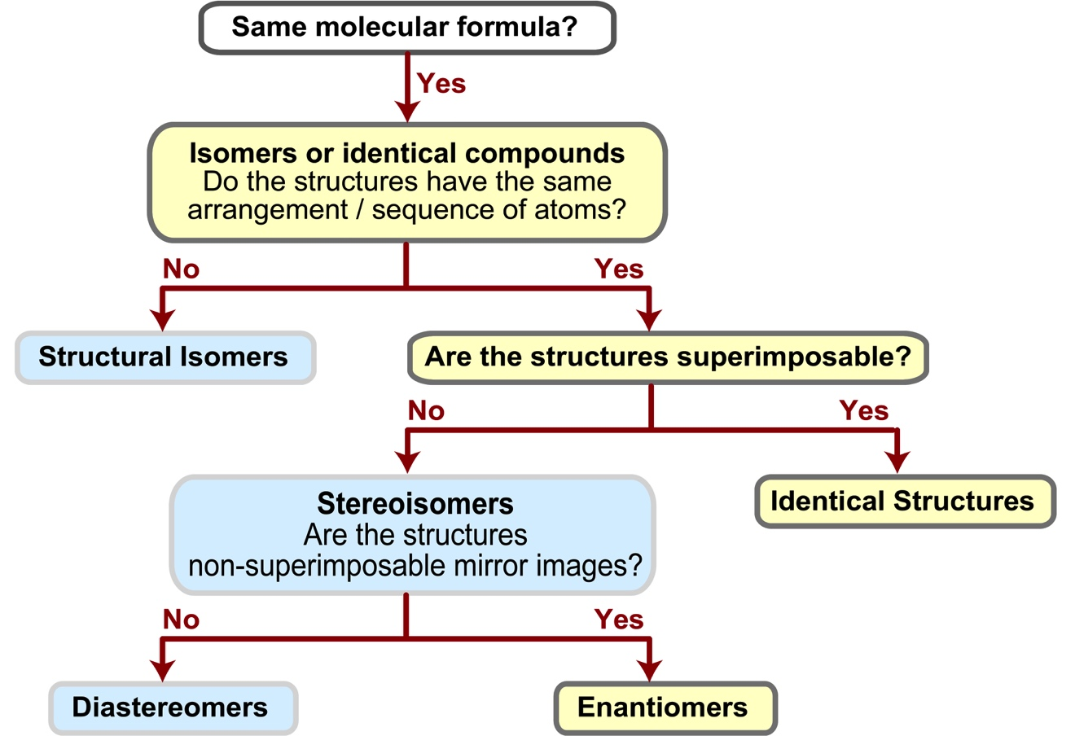

**Example** **1**:



NON-SUPERIMPOSABLE 🡪 Enantiomers

**Example 2**:



Identical structures, superimposable

**Example 3**:





**Example 4:**

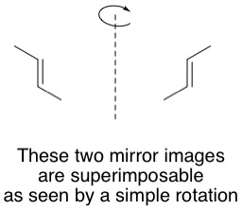

trans-2-butene is achiral

**Examples of determining chirality within molecules**



If there is plane of symmetry within a molecule, then the molecule is **achiral** (not chiral)