CHEM 261 Nov 6, 2020

**Addition reactions of Alkynes**

**Addition of H2O**

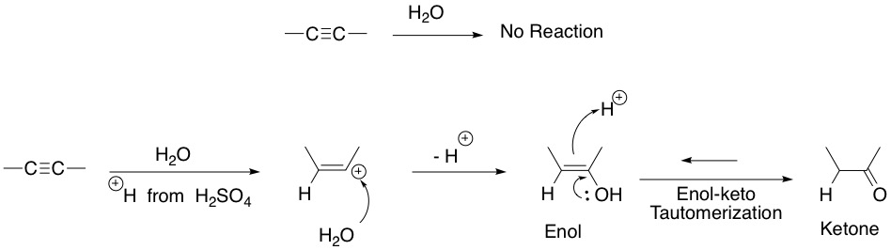

**Tautomers** are rapidly interconverting structural isomers. In the above example, the ketone and enol are tautomers.

**Example: 1-propyne**

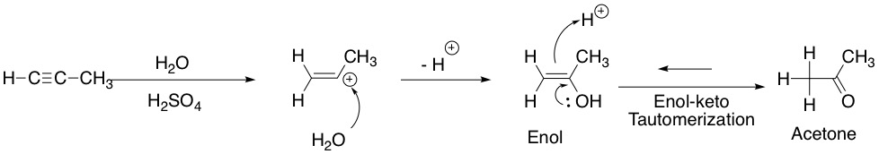

What if we want addition in anti-Markovnikov fashion?

Then we use a borane reagent!

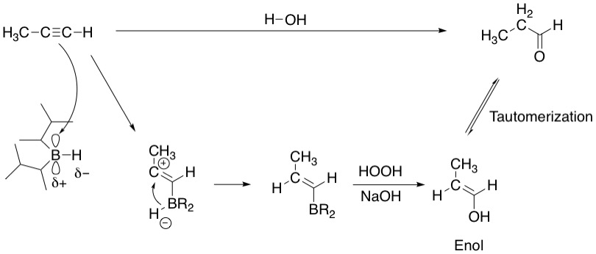

Notice how in the above examples with 1-propyne, depending on which reagents are used one can carry out a Markovnikov addition leading to a ketone or an anti-Markovnikov addition leading to an aldehyde.