CHEM 261 Nov 6, 2020

**Addition reactions of Alkynes**

Alkynes are more polar as they have more negative charge between the two carbons.

They are always more reactive than alkenes and so can be utilized in all addition reactions that alkenes can, except react faster.

The carbon-carbon triple bond is composed of two pi bonds and a sigma bond

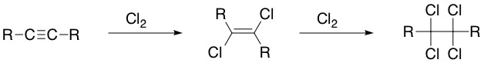

The first addition to the alkyne is anti, which forms the trans alkene.

**Hydrogenation of Alkynes**

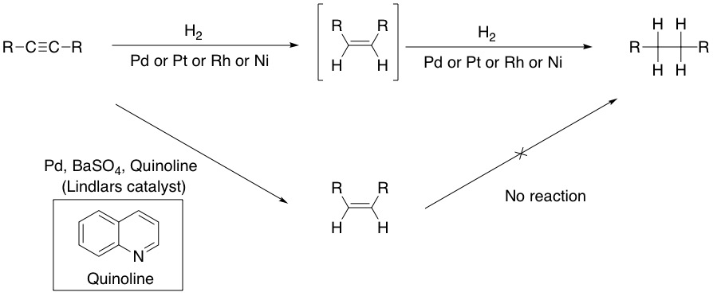

**Example: 2-butyne**

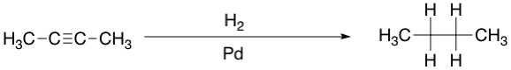

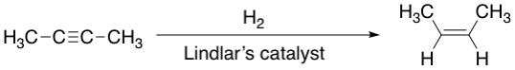

**HX Addition**

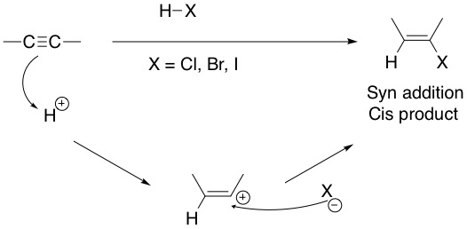

RECALL: Addition of HX across the double bond occurs in Markovnikov fashion

**Example: 1-propyne**

