CHEM 261 November 4, 2020

**Oxidation and reduction reactions**

Reduction adds electrons

Oxidation removes electrons

**Reduction Reaction**

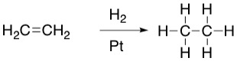

12 e- 14 e-

outer shell outer shell

As there is an increase in the electron count in the outer shell, this is a reduction of ethylene.

**Ozonolysis**



**Ozonolysis** (lysis = cleavage)

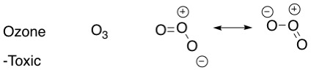

**Examples of carbonyl groups (part of many functional groups)**

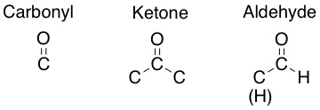

**Reaction scheme of ozone**



**Example**

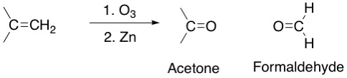

**Ozonolysis Mechanism** (lysis = cleavage)

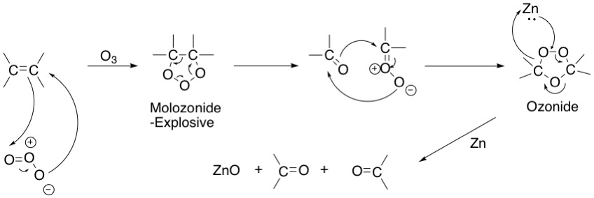

**Example**: Myrcene – C10H17

