CHEM 261 October 30, 2020

**Addition Reactions**

Hydrogen Halide (H-X)

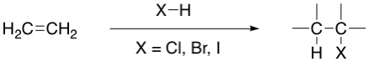

Reaction generally leads to syn/cis addition

**Example 1: Ethylene**

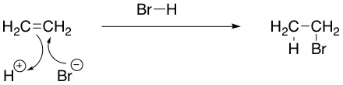

**Example 2: 1-Methylcyclopent-1-ene**

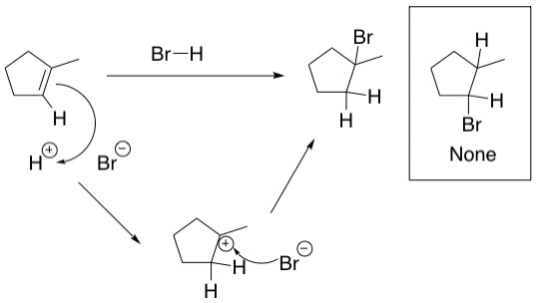

-Markovnikov addition

**RECALL:** Carbocation stability 3º > 2º > 1º > CH3+

**Hydration and ether formation**

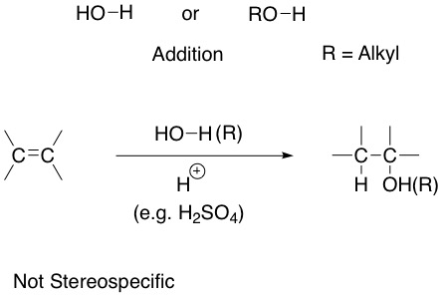

**Examples**

**Hydration (Water Addition)**

Ex #1)

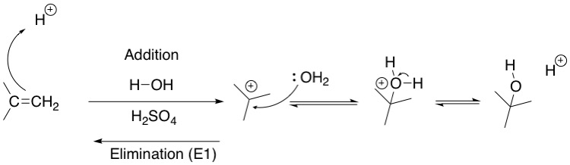

H2SO4 (H+) is a catalyst, meaning that it is not transformed or used up in the reaction but is present to lower the activation energy.

**Ether formation**

Ex #1)

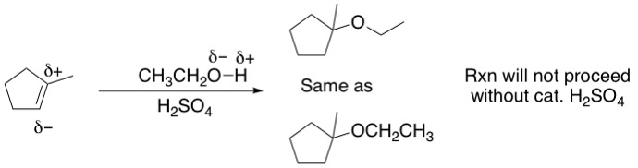

Ex #2)

