CHEM 261 September 28, 2020

**Conformation** Different 3D shapes of a single (the same) molecule obtained by rotation about single bonds

**Cycloalkane Conformations:**

**Cyclopropane** –bond angle 60o – relatively rigid structure, very reactive



Eclipsing interactions

**Cyclobutane** – bond angle close to 90o – does have some flexibility



3D structure of cyclobutane:

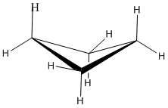

**Cyclopentane** – bond angles nominally 108o – more flexible than cyclobutane



**Cyclohexane** – bond angles actually 109o, not 120o as in flat hexagon



**Cyclohexane Conformations** – How to draw:

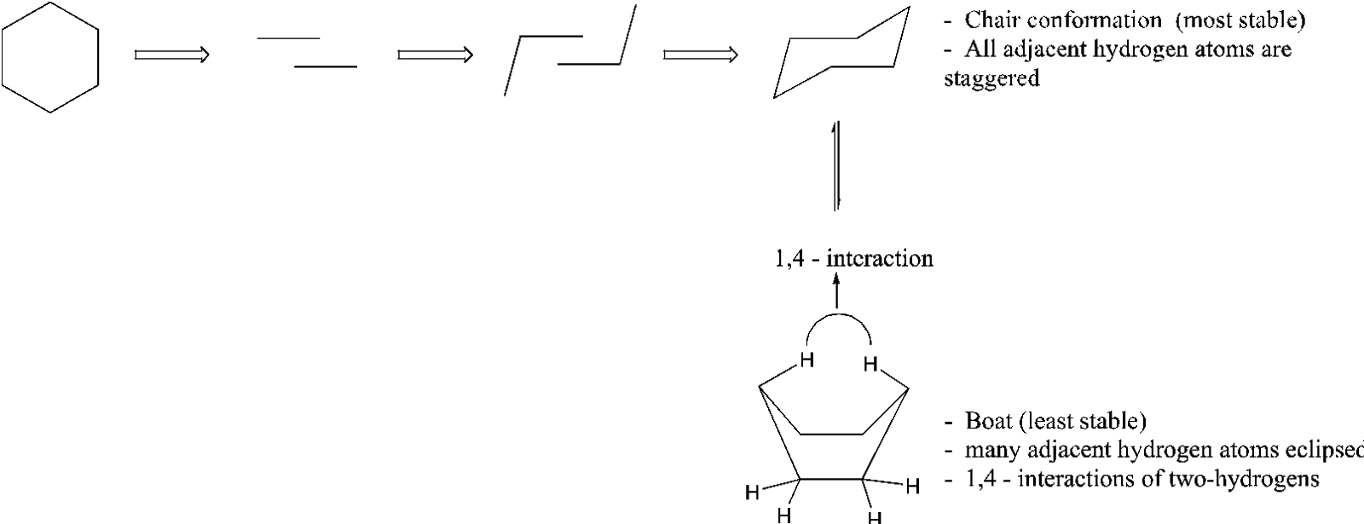

**Another way to draw cyclohexane**:

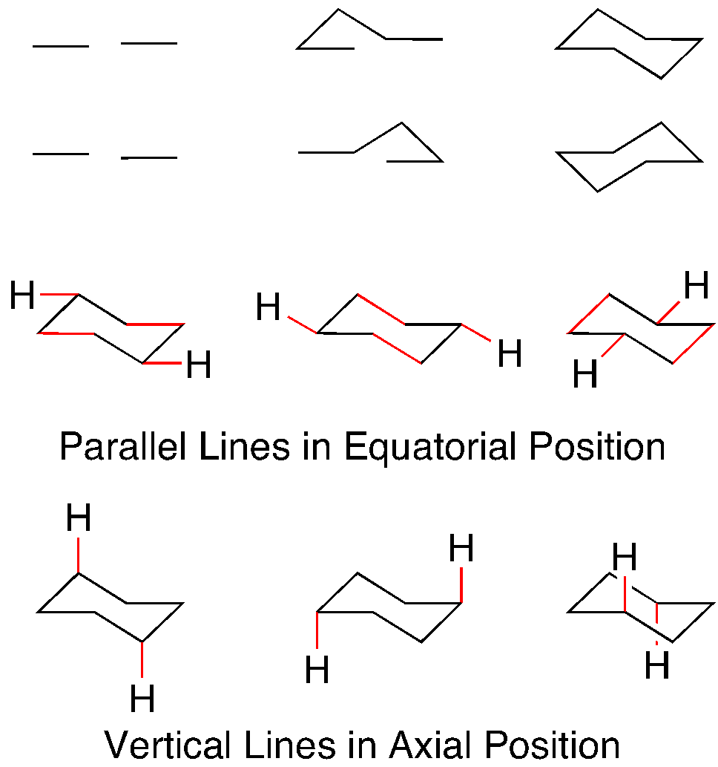



**Cyclohexane Conformations Axial vs Equatorial Positions**

