CHEM 261 September 28, 2020

**Conformation**

Different 3D shapes of a single (the same) molecule obtained by rotation about single bonds

**Example:** Ethane

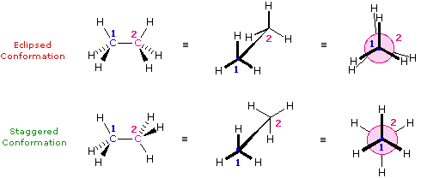

Most stable

Less stable

ΔG = 2.8 kcal/mol for rotation

At room room temperature (20 oC): 15-20 kcal/mol of energy available. This allows for rotation around C-C to occur rapidly at room temperature. – Important to know

There is a **Steric effect** between neighboring bonds to hydrogens: **Repulsion of filled shells of e-**

**Newman Projections**

This is a tool to examine the conformation (rotational 3D geometry) about one specific bond

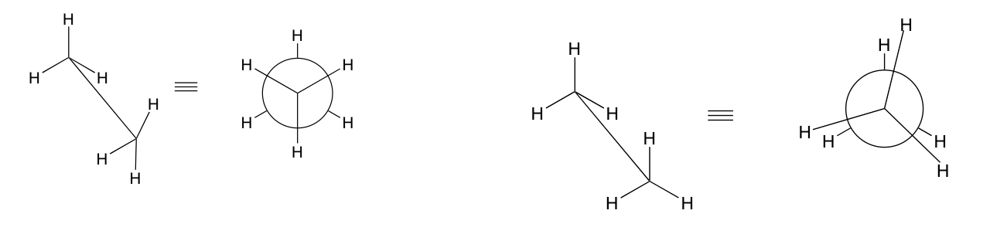

Staggered conformation (hydrogens are anti) Eclipsed conformation (hydrogens are syn)

Anti means opposite side - Syn means same side

**Example:** n-butane (C4H10)

Rotation around all bonds still very rapid.

Most stable (most populated conformation) is called anti and has groups as far away as possible.

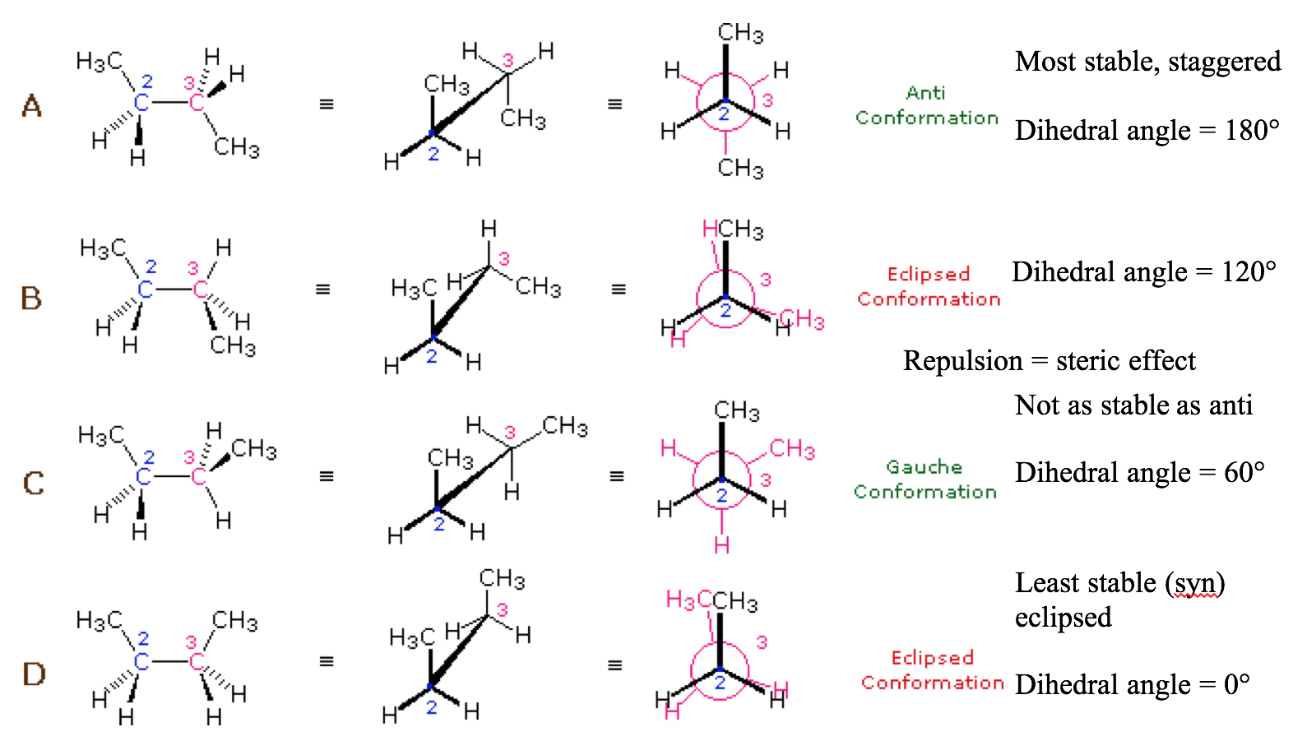  
Butane Conformational Energy Diagram:

