CHEM 261 October 26, 2020

**Addition Reaction:**

**General Mechanism**

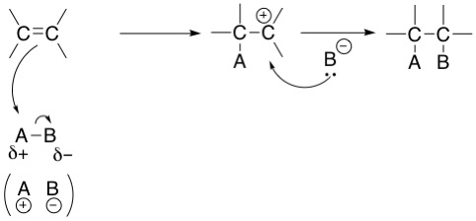

**Hydrogenation Addition of H2**

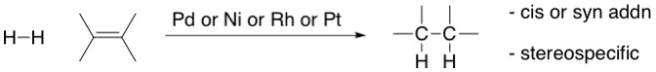

This reaction is **stereospecific**, meaning that the stereochemistry of the starting material determines the stereochemistry of the product (in this reaction, cis). The metals palladium (Pd), nickel (Ni), rhodium (Rh), and platinum (Pt) act as catalysts to facilitate this reaction.

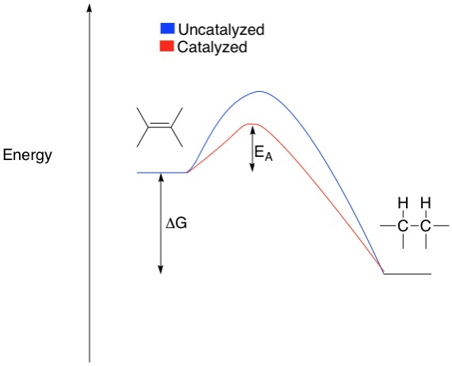

**Catalysts** accelerate the reaction rate by providing a lower energy pathway (red curve above).

In general, they are not permanently converted to other products

**Mechanism of hydrogenation**

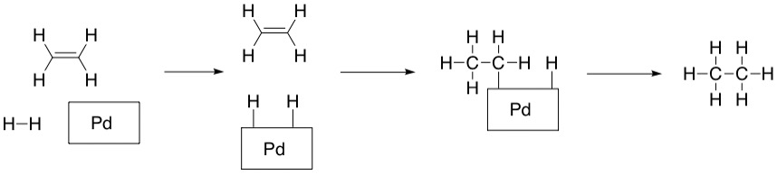

**Hydrogenation examples**

**Example 1**: 1,2-dimethylcyclobutene

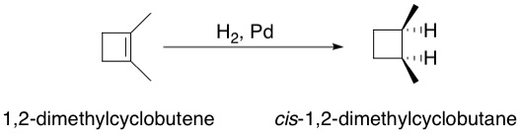

The hydrogenation can occur from the top or the bottom, which in this case produces the same product (cis isomer of 1,2-dimethylcyclobutane).

**Example 2:** Pentene

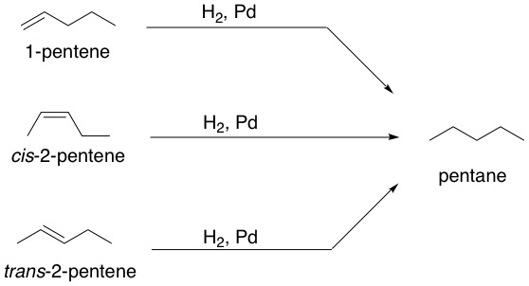

Energy is released in each of these reactions, the energy released implies stabilization caused from transforming the starting material into the product.

**Energy diagram**

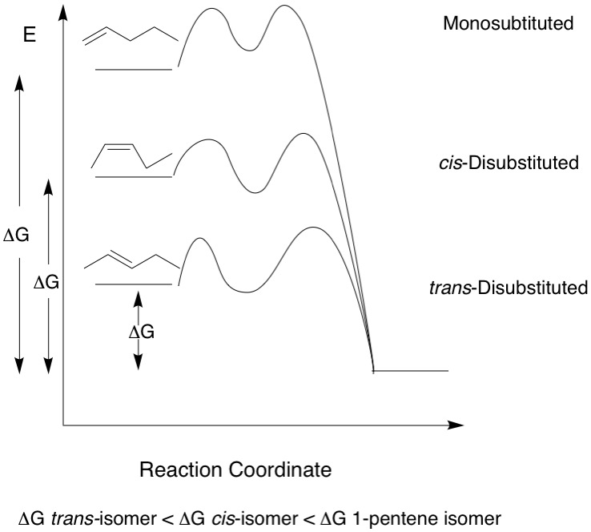

Alkenes with more substituents are more stable. Carbons in a double bond have a , this is stabilized by the electron donating effects of alkyl groups. Hydrogens are less electron donating and so less substituted alkenes are less stable. Cis alkenes are less stable than trans alkenes as they have methyl groups facing the same direction which causes unfavorable steric interactions.

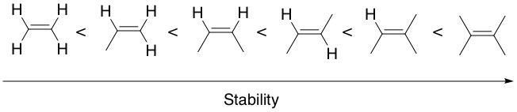

**Example 3:** Fats

**Fat**

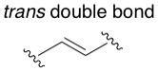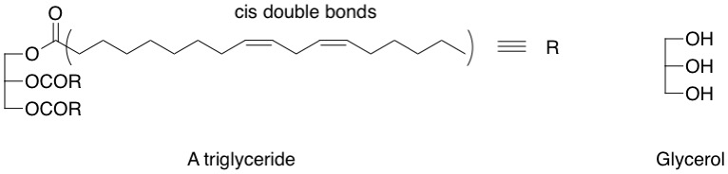

The triglyceride is a triester of glycerol

It is a polyunsaturated (>1 double bond) fats (e.g. canola oil)- unsaturation refers to the double bonds.

Trans double bonds can also be generated in fats, which are then called trans fats.

Hydrogenation give saturated fats (unsaturation remobed)

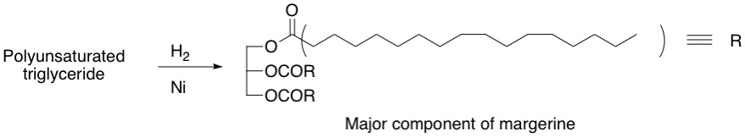

A solid saturated fat (margarine)

This molecule has greater London dispersion forces, cause it to exist as a solid

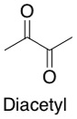

Butter flavoring that adds a yellow color

**Example 4**: Steroid

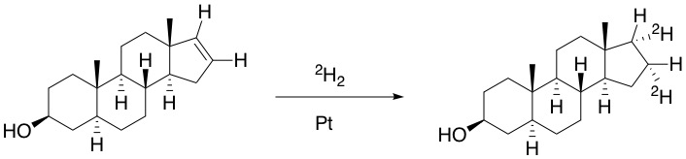

The deuteriums add to the back because of the steric hindrance of the nearby methyl group.

2H = D = deuterium

**Example 5:** Limonene

Limonene

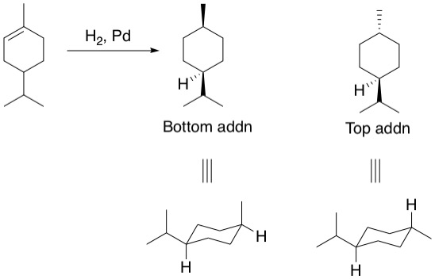

The two possible products are diastereomers.