CHEM 261 Nov 23, 2020

**Addition Reactions to Alkenes Using Radicals: Polymers & Polymerization**

Recall Previous Addition Reaction of Alkenes Using Cations (e.g. H+)

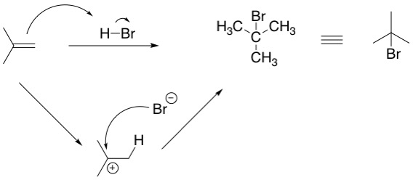

Can addition occur in opposite sense ? Yes if use radical addition

**For alternate regiochemistry (addition of Br onto the less substituted carbon) need dialkyl peroxide**

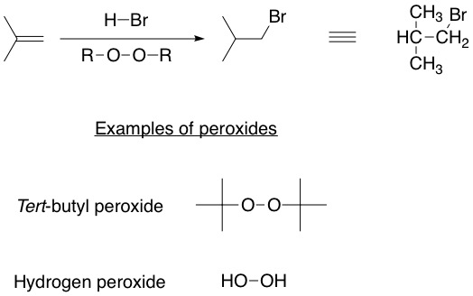

**Radical mechanism**

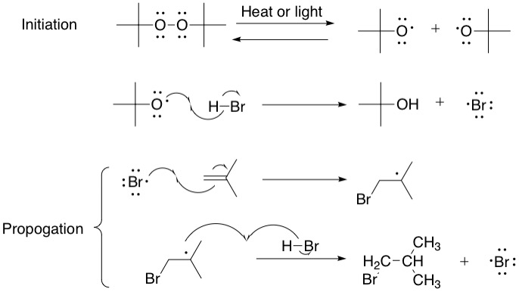

**Example without HBr – a polymerization reaction occurs**



When 2 radicals meet, chain terminates

Note more stable radical (in this case tetiary) is always formed by addition onto double bond. There is a termination step (not shown) that ends this polymerization. It requires combination of 2 radicals. It could be two growing chain radicals meeting or it could be from peroxide. If less peroxide is used the polymer chain will be longer.

**Polymers**

Poly = many

Meros = parts

**Examples of Biopolymers**

1. Polysaccharides

- polymers of sugars

1. Proteins and peptides

- polymers of amino acids

1. Nucleic acid polymers (DNA and RNA)

- polymers of nucleotides

1. Fats and polyketides

- polymers of fatty acids

1. Polyisoprenoids/ terpenoids

- polymers of isoprene

**Polymer formation**

**Teflon**

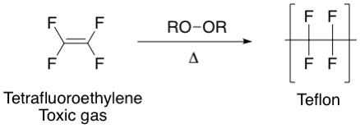

Many polymers degrade into their components if heated enough, and can further decompose.

**Polyethylene**

