CHEM 261 October 21, 2020

Nomenclature of Alkynes
Rules:
- Find longest chain with max number of multiple bonds
- Number from end to give 1st multiply bonded position the lowest number
- Drop “ane” and add “yne”
- For multiple triple bonds, drop “ne” and add “diyne”,” triyne”, etc.

ethyne
acetylene

Multiple alkynes end with:

Mixed double and triple bond containing compounds are “eneynes”

Example 1:

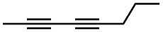

2,4 - Octadiyne

Example 2:

The below example is from canola – defense substance (anti-nematode)

Parent alkane of 13 carbons is tridecane – hence trideca

3E,11E-trideca-1,3,11-triene-5,7,9-triyne

Characteristics of Alkanes, alkenes, and alkynes

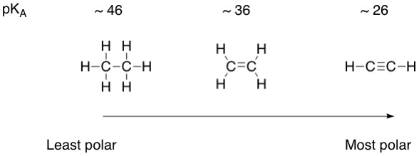
Alkynes have higher boiling point, melting point, and density

