CHEM 261 October 21, 2020

**Alkene and Alkyne Nomenclature**

**E, Z - Nomenclature**

E - Entegegen - Opposite

Z - Zusammen - Together

Naming based on atomic number, similar process to identifying S/R stereochemistry

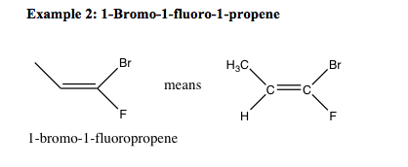

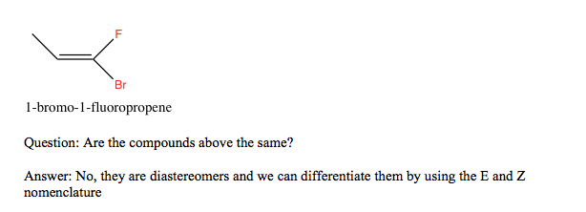

**E, Z - Nomenclature**

E - Entegegen - Opposite

Z - Zusammen – Together

**Example 1:** **1-bromo-1-fluoro-1-propene**

- compare the atomic no. of the adjacent atoms.



 

**Example : 1,3-dibromo-1-fluoro-2-methyl-1-propene**



Therefore the name is: (Z)-1,3-dibromo-1-fluoro-2-methyl-1-propene

If you cannot decide on basis of atomic number of atoms directly attached to double bond, go to the next set of atoms until a higher atomic number is found

**Example 3:**

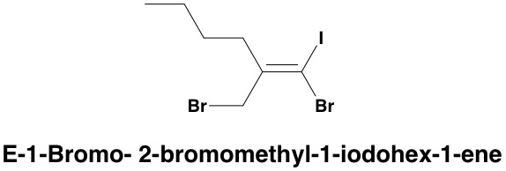

Iodine is on the opposite side to the bromomethyl (highest priority groups on either side of the alkene) and so the stereochemistry is deemed E.

**Nomenclature of Cycloalkenes**

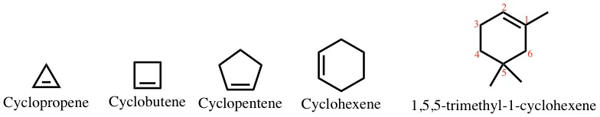

**Nomenclature of alkenes with multiple carbon-carbon double bonds (poly-enes):**





Drop -ne and add “diene”, “triene”, etc.

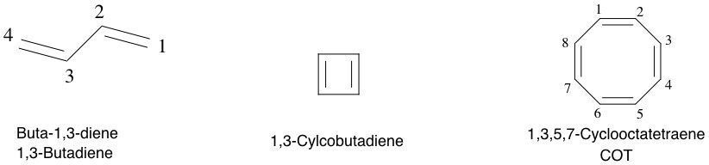

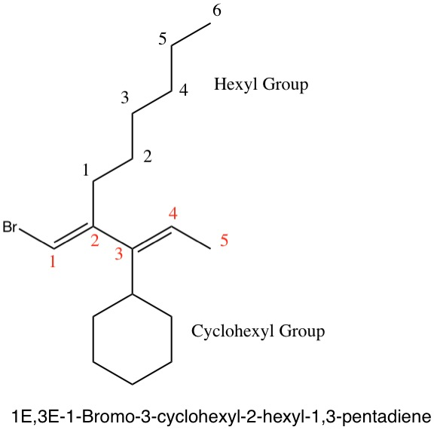

Note: Carbons attached to double and triple bonds are depicted as additional carbon-carbon bonds in the representations

**Special Nomenclature of Common Groups:**

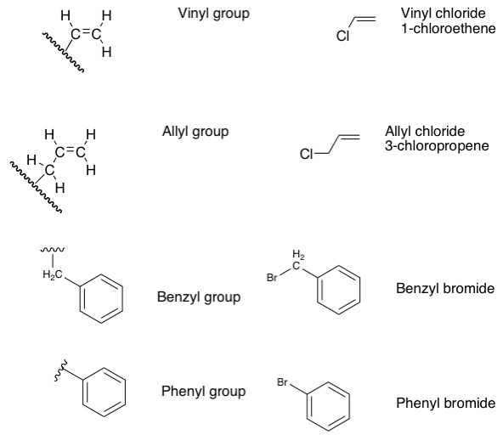

phenyl bromide is commonly called bromobenzene