CHEM 261 October 21, 2020

Lecture Outline 4: Alkenes, Alkynes

**Alkene and Alkyne Nomenclature**

Alkene = double bond = olefin (oleum facere = to make oil)

Alkyne = triple bond = acetylene (as functional group, not compound)





Simplest Alkene and Alkyne Possible

**Alkene Nomenclature**

Find longest chain, number from end to contain both ends of C=C and give lowest number to 1st C of C=C

Change “ane” to “ene” precede with number to indicate first double bond position

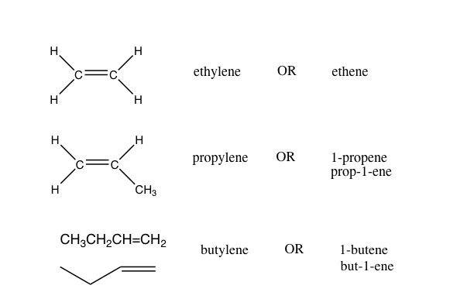

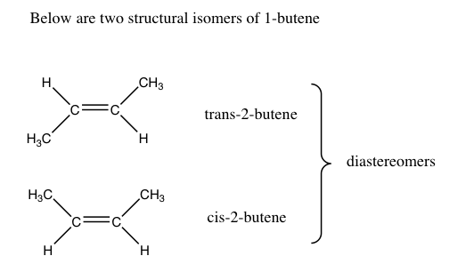

**Example 1: 6-Bromo-2-hexene**

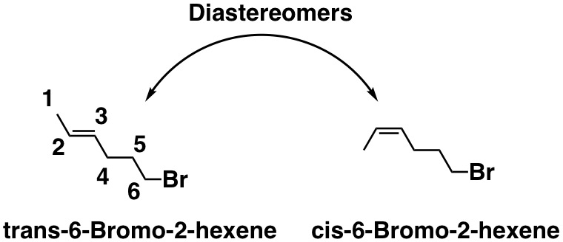

In the cis isomer, the two higher priority groups on either side of the carbon-carbon double bond are pointing in the same direction.