CHEM 261 October 2, 2020

**Example: Bromination of cyclohexane**

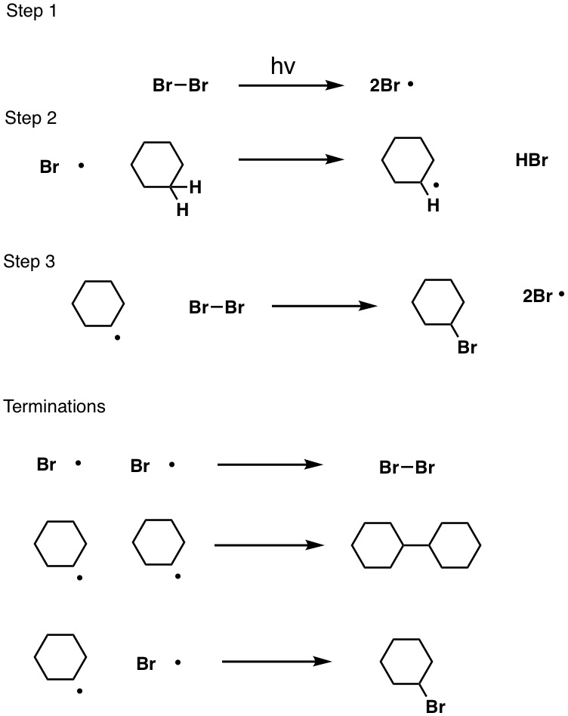

**Example: Methylcyclohexane**



**Other Examples:**





The reaction can utilize either heat (Δ) or light (hν)

Different types of hydrogen can be pulled from a methylcyclohexane in a radical halogenation reaction to give various products. However, one main product is obtained. This is explained in terms of the stability of the radical formed during the reaction process.

**Stability of radicals:**

* Stability increases with alkyl substitution
* Alkyl groups are polarizable and donate electrons to electron deficient sites better than hydrogens (this is called **inductive effect** and occurs through sigma bonds)



**Or it can be summarized from least to most stable radicals:**

**.**CH3 < **.**CH2R < **.**CHR2  < **.**CR3

methyl primary (1°) secondary (2°) tertiary (3°)

radical radical radical radical

(least stable) (most stable)

**More Examples**

**A. 1,1,3-trimethylcyclopentane bromination**

 

1,1,3-trimethylcyclopentane

**B. 2,2,4-trimethylpentane chlorination**



2,2,4-trimethylpentane



