CHEM 261 October 2, 2020

**Reactions of alkanes**

1. **Combustion:**

**∆**=**heat**

R-H + O2 CO2 + H2O

R = any alkyl group

**General formula for combustion reactions:**

C*n*H2*n*+2 + ( +) O2 (*n*+1) H2O + *n* CO2

**e.g. propane**

**∆**

 5O2 3CO2 + 4H2O

CH3CH2CH3

1. **Halogenation of alkanes**

**h**

R-H + X2 R-X + HX

R = any alkyl group, R-X = alkyl halide / haloalkane (X= Cl, Br, F); F2 is the most reactive and I2 fails to react.

    h = Planck’s constant 6.6 x10-34 joules-sec

  frequency of light

E = **h are the symbols we use to describe light energy**

**Substitution reaction** (via radicals) – Substitute H with X

e.g. Chlorination of methane









**Mechanism of reaction:**

* Step by step description (proposal) of a reaction process (hypothetical and difficult to “prove”)

**Two kinds of mechanism**

1. **Homolytic** (radical): One electron goes to each atom once the bond in broken. e.g. Free radical halogenation of alkanes

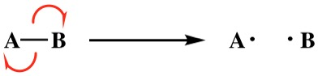

The red half arrows above describe the movement of one electron, full arrows describe movement of lone pairs.

2. **Heterolytic** (polar reaction): The electron pair goes to one of the atoms once the bond is broken. e.g. Addition reactions of alkenes; elimination reactions



Homolytic reactions are less common than heterolytic reactions

- Initiated by heat (Δ) or by light (h

**Mechanism of halogenation of CH4:**

h

CH4 + X2 CH3X + HX

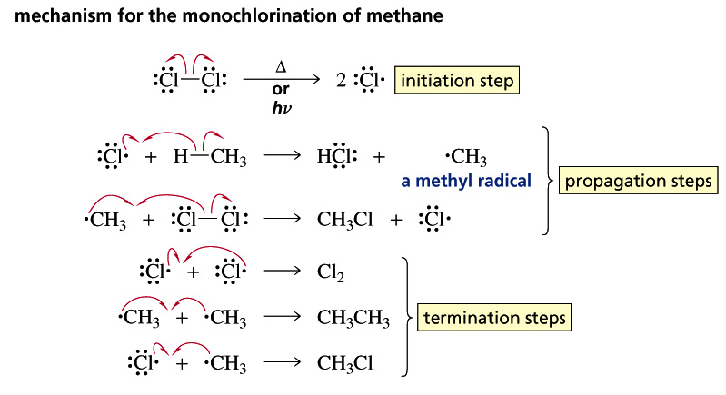

X = F, Cl, Br

Propagation is the main step within the process. The termination step is the combination of radicals and is quite rare during the progress of the reaction, yet any one of the three listed can occur to terminate the reaction.

Note: The above mechanism also applies to other halogens (F, Cl, Br; not I)

**Example: Ethane (analogous)**

