CHEM 261 November 2, 2020

Hydroboration

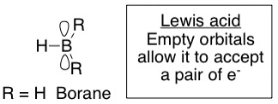

Structure of borane

Exists as Diborane (B₂H₆), but behaves like BH₃
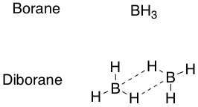

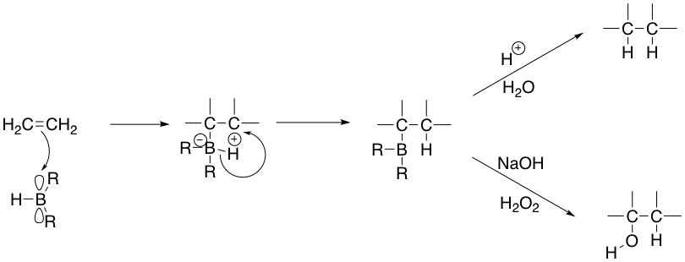
Stereospecific
syn/cis addn.

Cis addition for both reactions

Like H₂/ Cat.
(Pd, Pt, Ni, Rh)

Example

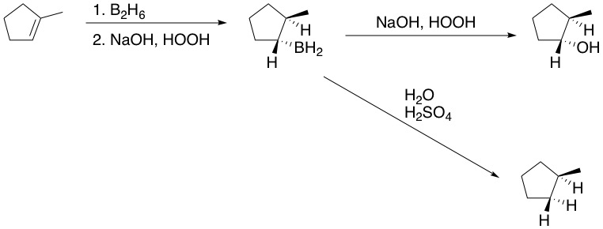
*
*
Syn addition, but anti-Markovnikov add’n of OH

