CHEM 261 September 18, 2020

**Electromagnetic Radiation:**

Infrared (IR) Spectroscopy – Background only:

E = hc/λ = h , energy is quantized

E = Energy

h = Planck’s Constant= 6.6 x 10-34 joules/sec

 = Frequency

λ = Wavelength

c = Speed of light = 3.0 X 1010 cm/sec

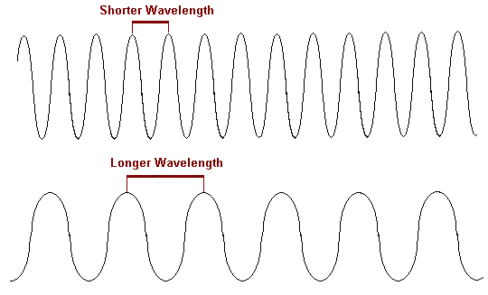

* Longer Wavelength
* Low Energy
* Low Frequency
* Shorter Wavelength
* Higher Energy
* Higher Frequency

NB: There is an inverse relationship between wavelength and frequency.

**Electromagnetic Spectrum:**

NB: 1nm = 10 angstrom

800nm=8000‎Å

400nm=4000‎Å

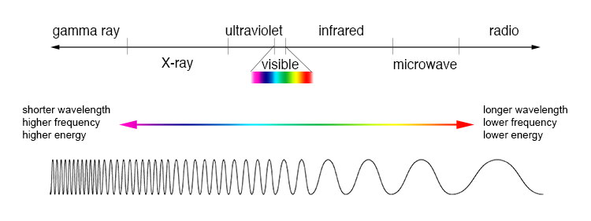

UV and visible light: conjugated double bond systems

e.g. C=C bonds absorb UV light and some visible light

**Infrared Radiation: bond stretching and bending modes**

-Measured in wavenumbers (cm-1)

- Defined as cycles/second

e.g. O-H bond can be seen around ~3400cm-1 in an IR spectrum



