CHEM 261 Nov. 18, 2020

**Dehydrohalogenation**





**Example**



**Example #2 B: Start with different sterochemistry get different product stereochemistry (a diasteromer)**



**Example #4: bulky nucleophiles/bases favour elimination**



**Example #5: small nucleophiles/bases favour substitution**



**Limitations and Considerations**



need hydrogen on adjacent carbon for loss of HBr

**Limitations and Considerations**

**Example:**



**Bredt Rule**: Bridged alkenes are only okay if one of the bridges is a “zero” (0) bridge in small rings <9



To determine whether an elimination can occur, ask yourself three questions:

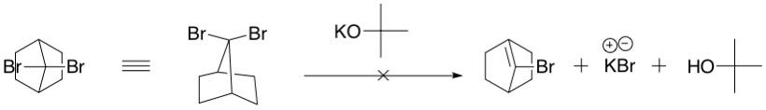

1. Is there a good leaving group present?

Eg. Yes, Br is a good leaving group

1. Is there a hydrogen on the carbon next to the carbon containing the leaving group?

Eg. Yes, on the bridge-heads on either side of the carbon containing the Br.

1. Is Bredt’s Rule being followed?

Eg. No, if a double bond was being formed, it would be at a bridge-head and Bredt’s rule states that a double bond cannot be formed at a bridge-head if the rings are small and all bridges >0. (double bond too strained)

Substitution would likely not occur either as the electrophilic site is hindered (tertiary carbon).