CHEM 261 October 16, 2020

**Substitution Reactions**

**Remember:** Radical Substitution



Proceeds by a radical mechanism

**Ionic Substitution:**



**Nucleophile** is a substance that seeks positive charge

**Types of Nucleophilic Substitution (SN)**

SN1 - rate depends on 1 concentration

SN2 - The rate is dependent on the concentration of the nucleophile and the nucleophile (2 concentrations)

**Sn2 Mechanism**

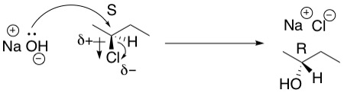

Reverse reaction will not occur.

- Inversion of configuration.

- **Concerted**: The bonds of the starting material break at the same time that the product bonds form.

- **Stereospecific**: stereochemistry of the starting material determines the stereochemistry of the product.

**Energy Diagram of SN2 Reaction**

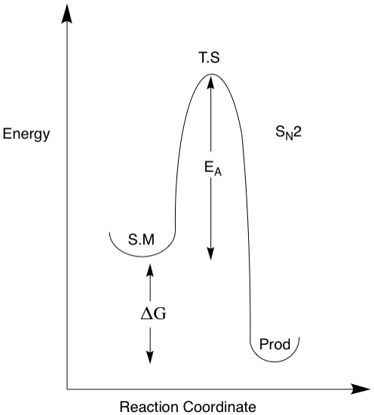

There is no intermediate in the SN2 reaction, as it is concerted

SN2 will **not** occur on carbon sites that have multiple bonds.

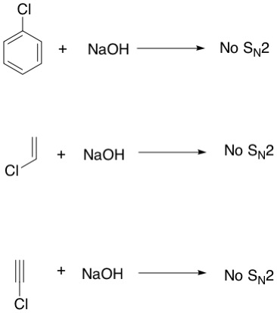

**SUMMARY**

- SN2 is stereospecific – proceeds with inversion of configuration (known as Walden inversion)

- Rate depends on two concentrations (bimolecular)

- Best if 1º halide, OK if 2º, Never on 3º, or C=C.

**Never leaving groups: (negative charge not stabilized):**



Fluorine, though electronegative, is a bad leaving groups as it is small and poorly solvated.

**Good leaving groups**

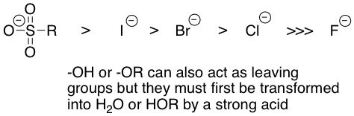

OH and OR can ONLY leave as water (HOH) or alcohol (HOR) never as anions

**Example 1 (will not proceed to products)**

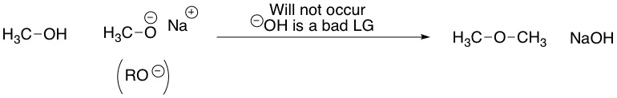

- The reverse reaction will also not occur as (-)OR is also a bad leaving group (LG).

**Example 2 (will give products by SN2 due to prior protonatgioon with HOH as leaving group)**

Alcohols require an acid catalyst to transform them into a good leaving group (H2O)

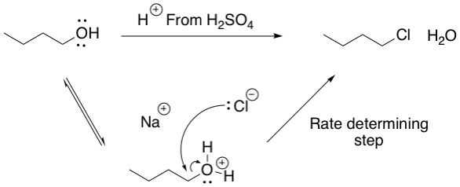

**Examples 3 & 4 (SN2 Reactions)**

Top one has achiral starting material and gives achiral product

Bottom one has single diastereomer (trans-1-chloro-4-methylcyclohexane starting material is not chiral due to plane of symmetry within molecule). SN2 Reaction gives inversion of configuration to produce single cis diastereomer (cis-4-methylcylohexan-1-ol ; you need not know how to name this yet)



