CHEM 261 Nov 16, 2020

**Synthesis of Alkenes and Alkynes**

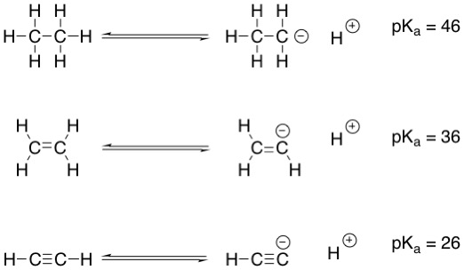

Equilibrium lies to the left in each of these reactions as alkanes, alkenes, and alkynes are very weakly acidic.

**Deprotonating acetylenes**

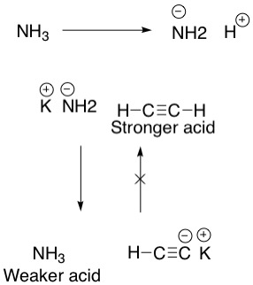

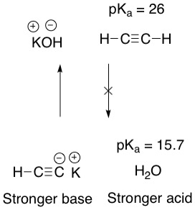

KOH will not deprotonate acetylene because it is a weaker base than acetylenes conjugate base (acetylide).

On the other hand KNH2 will deprotonate acetylene, as the resulting acetylide is a weaker base. Ammonia pKa is 36

**Organic synthesis example:**

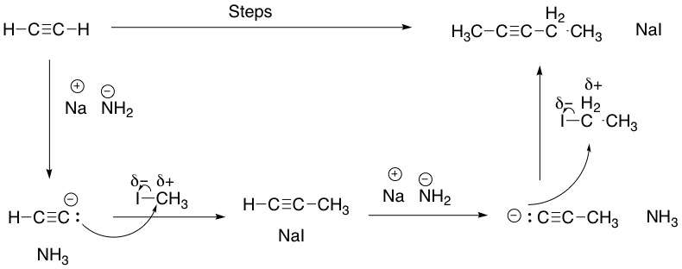

Both substitution reactions involving methyl iodide and ethyl iodide are SN2, as the primary and secondary carbons will not hold the positive charge that is characteristic of an SN1 intermediate (tertiary carbocation).

**Example:**



Alternative solution to above problem:

