CHEM 261 Oct 14, 2020

**Fischer Projections**

A method of drawing chemical structures, where the horizontal components are coming towards you and the vertical ones are going back.

**Example #1:** Lactic Acid



**Example #2**: Tartaric acid



Meso compounds have stereogenic centers but contain a plane of symmetry and are achiral

Racemic mixtures (or racemate) contain a 1:1 ratio of each enantiomer

**Physical Properties of Enantiomers**

* Same physical properties with achiral agents or procedures
  + Melting point, boiling point, solubility in achiral solvents
* Enantiomers behave differently with chiral agents
* Diastereomers have different physical properties (m.p, b.p, density, solubility)

**Optical Activity**

* Rotation of plane of polarized light
* α = measured rotation (o)
* [α]D = Absolute rotation
  + (+) (clockwise)
  + (-) (counter-clockwise)
* Absolute rotation is 0 o for achiral molecules

**Pure enantiomers show equal but opposite rotation**

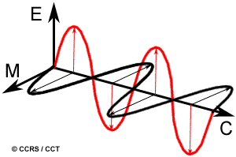

End on view of vector

components of normal light. It is possible to polarize light and remove some of those vectors.

Light has an oscillating electric field (red)

combined with a magnetic field (black)

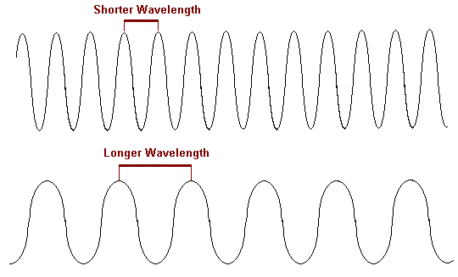

* Longer Wavelength
* Low Energy
* Low Frequency
* Shorter Wavelength
* Higher Energy
* Higher Frequency

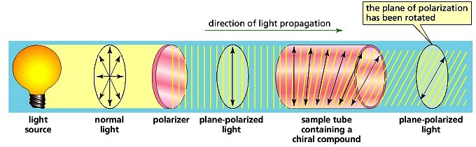

**Optical Rotation**

Factors affecting optical rotation:

* Concentration of compound (c)
* Path length that light travels through the solution (l)

[α]D = Absolute rotation at the D line of sodium (589 nm or 5890 Å)



α = measured rotation (o) c = concentration (g/cm3) l = path length (cm)

D = D-line of sodium light [α] = absolute rotation

Degrees (o) = + : Clockwise

- : Anticlockwise

Example: Carvone

[α]D = - 100 o [α]D = + 100 o



S-carvone (caraway) R-carvone (spearmint)

**Calculating Optical Purity**

For this example for S-carvone, assume the pure S enantiomer has +100o rotation

|  |  |  |  |
| --- | --- | --- | --- |
| **R** | **S** | **Rotation (o)** | **Optical Purity (%)** |

|  |  |  |  |
| --- | --- | --- | --- |
| 100 % | 0 % | -100 o | 100 % |
| 75 % | 25 % | -50 o | 50 % |
| 50 % | 50 % | 0 o | 0 % |
| 25 % | 75 % | +50 o | 50 % |
| 0 % | 100 % | + 100 o | 100 % |

If a solution is an equivalent mix of 1:1 R + S enantiomers, α measured = 0 o

A 50:50 mixture of enantiomers is called a *racemic mixture* (or racemate)

Optical Purity (measured experimentally) = Enantiomeric Excess (ee) (Theoretical value)

**Resolution of Enantiomers**

Definition: separation of two enantiomers

- Requires a chiral reagent

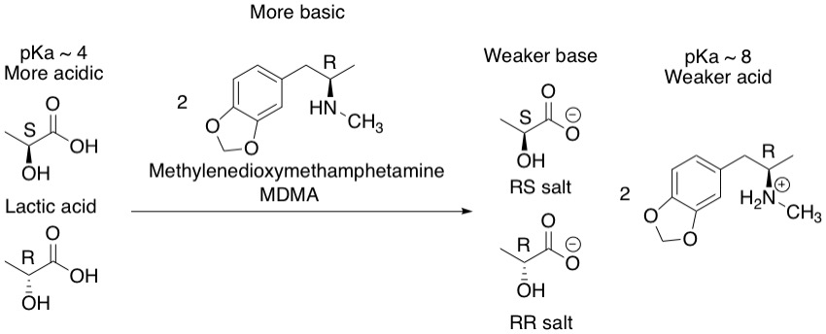

The starting material lactic acids are enantiomers of each other.

By reacting enantiomers to make a salt with an enantiomer of MDMA (another chiral molecule), one can obtain salts which are now diastereomers of each other (RS and RR). The resulting diastereomers have different melting points, boiling points, solubilities, and can be separated by crystallization.