CHEM 261 October 09, 2020

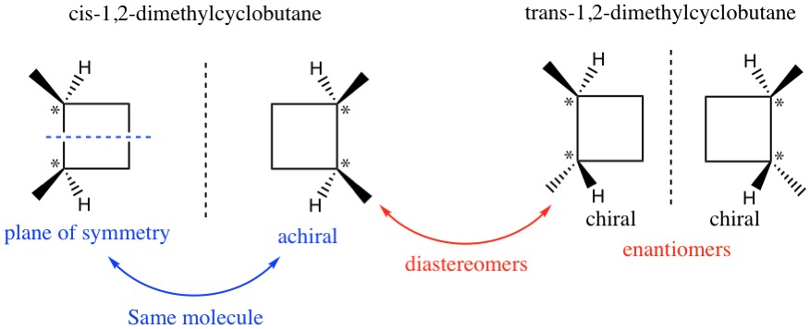

*\* indicates a chiral center*

Diastereomers have different physical properties (e.g. mp, bp, etc), and can be separated.

Stereogenic centers can exist in a molecule but if there is a plane of symmetry, it renders the whole molecule achiral.

**Note: a chiral center (or stereogenic center) exists if *4 different groups* are attached to the carbon in question**

If there is plane of symmetry within a molecule, then the molecule is **achiral** (not chiral)

**R/S Nomenclature:**

R and S designation of stereoisomers

* R = Rectus (right, clockwise)
* S = Sinister (left, counterclockwise)

Labeling a stereogenic center as R or S:

* Identify all stereogenic centers (i.e. 4 different substituents)
* Look at atomic number of atoms attached to the stereogenic center
* Assign priority based on atomic number. If you cannot decide, go to the next set of atoms.
* Number from highest to lowest priority, then with the lowest priority group pointing back, count 1, 2, 3:
  + Clockwise 🡪 R configuration
  + Counterclockwise 🡪 S configuration

Each stereogenic center in a molecule is analyzed separately

**Example**:



Bromine has the highest atomic number (35), followed by chlorine (17), then fluorine (9), and lastly hydrogen (1).

What if the lowest priority group is pointing forward?

Counting 1, 2, 3 gives clockwise, BUT the smallest group is pointing forward, so the configuration is opposite of what you get if the smallest group is back

In this case, the configuration of the stereogenic center is “***S”***

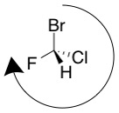

**Example**

CONIINE, Poison hemlock, potent neurotoxin, killed Socrates

Stereogenic center (chiral centers or asymmetric centers) is circled in red



The nitrogen is nominally a steregenic center since it has 4 different substituents, however it inverts rapidly, and so is not considered stereogenic.



To draw the enantiomer of coniine, invert the geometry at the sterocenter



**Example of determining priority of groups in enantiomer on natural coniine**

- We can assign highest priority to the N and lowest to the H, but cannot immediately tell which carbon attached to the stereocenter is of higher/lower priority. When this is the case, we look at the next substituents in the chain.



* We cannot tell at the second attached carbon, so we move on to the third.
* We still cannot tell at the third, so we move on to the fourth.
* At the fourth carbon we can see a difference. The carbon that is part of the propyl group ends in a CH3 so it is bonded to three H, and the other carbon is bonded to two H and one C. The propyl group gets lower priority (3) and the other group gets higher priority (2).
* Counting 1,2,3 🡪 clockwise is *R*. This is the *R* enantiomer.

**Cholesterol - A steroid with stereogenic centers (red circles)**



**2**

**1**

**3**

**4**

**NB:** Stereochemistry of carbon bearing the hydroxyl is **S**

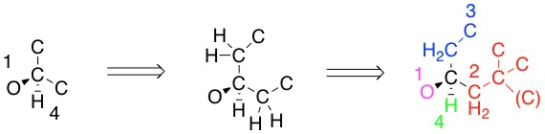

Carbon in brackets represents the carbon-carbon double bond.

**Enantiomer of cholesterol:**

To make the enantiomer of cholesterol, invert every stereogenic center

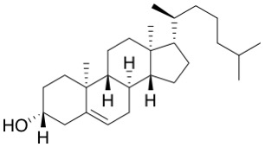

**Stereoisomer calculation:**

If only some (not all) stereogenic centers are inverted, then a diastereomer of cholesterol is produced.

8 stereocenters identified in cholesterol:

2n = 28 = 256 stereoisomers, which are divided into three kinds below:

1 Cholesterol (the bioactive natural product)

1 enantiomer of cholesterol

254 are diastereomers of cholesterol