CHEM 261 Nov 20, 2018

**Addition reactions of Alkynes**

**Oxidation of Alkynes**

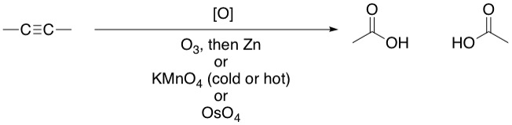

Any of the reagents shown can be used on an alkyne to produce the acids shown on the right.

**Examples: 1-propyne**

