CHEM 261 November 4, 2020

Oxidation and reduction reactions

Reduction adds electrons
Oxidation removes electrons

Reduction Reaction
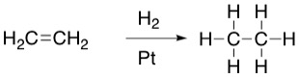
12 e⁻ 14 e⁻
outer shell outer shell

As there is an increase in the electron count in the outer shell, this is a reduction of ethylene.

Ozonolysis

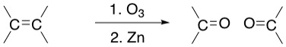

Ozonolysis (lysis = cleavage)

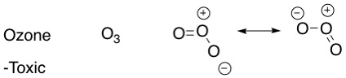

Examples of carbonyl groups (part of many functional groups)

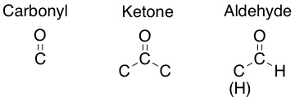

Reaction scheme of ozone

Example

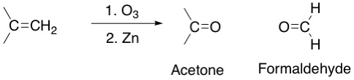

Ozonolysis Mechanism (lysis = cleavage)

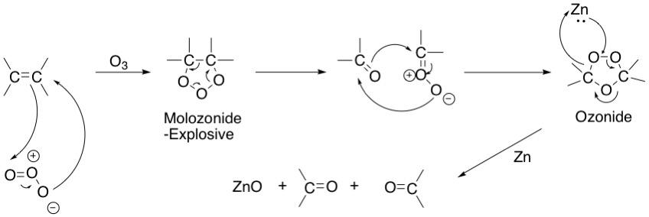

Example: Myrcene – C₁₀H₁₇

