CHEM 261 Nov. 25, 2020

**Conjugated Systems**

Definition: Systems that are separated by exactly one single bond from a double bond

**Compounds containing conjugated systems:**

**Polyenes:**

Example:



Double bonds are separated by one single bond

**Aromatic Compounds:**

1. Cyclic
2. Conjugated throughout
3. Planar
4. 4n + 2 electrons, where n is an integer (n=1,2,3,4….)

n cannot be 0.5

****Example: 1,2-Dibromobenzene



**Aromatic Compounds Are Not Like Alkenes**

much less reactive

**Benzene:**

* 36 kcal/mole more stable than is expected

**Conjugated Intermediates:**

Conjugation stabilizes the

positive charge



1) Cation:

2) Radical:

Conjugation stabilizes the

radical



Conjugation stabilizes the

negative charge

3) Anion:

**Polyenes:**

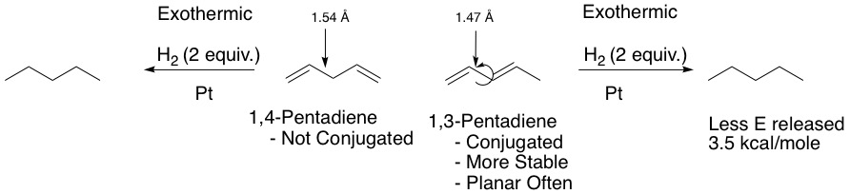

1,3-Pentadiene is planar often so that p-orbitals can overlap as seen below. The partial interaction of orbitals in the middle bond shortens the bond length due to partial double bond character. There is still rapid rotation about the single bond between the two double bonds, but the preferred conformation all pi bonds aligned. (Transoid preferred over cisoid)

