Carbohydrates (C_{N}H_{2N}O_{N})

sugars, saccharides

A familiar equation:

- about 4 x 10¹¹ metric tons of carbon dioxide is converted into glucose by plants
- the process of photosynthesis only uses 0.02% of the suns total energy on Earth
- the sugar produced is known as D-glucose, shown below in a Fischer Projection

Nomenclature of Sugars
3 carbon sugar (C₃) – triose
4 carbon sugar (C₄) – tetrose
5 carbon sugar (C₅) – pentose
6 carbon sugar (C₆) – hexose

General formula of sugars: C_{N}H_{2N}O_{N} (approx.)
The number of carbons is indicated as follows:

Example 1: Glycerol
Triose

Example 2: D-Glucose

D-Glucose is an Aldohexose

The carbonyl group is indicated by the prefix:

aldo – aldehyde
keto – ketone

Note: The sugar backbone is numbered such that the C=O is assigned the lowest number possible.

Additionally, an allocation of D or L is given to indicate the stereochemistry of the highest numbered (last) stereocentre.

D sugar – highest numbered stereocentre in R configuration.
L sugar – highest numbered stereocentre in S configuration.

Example 2: D-Fructose

Based on the above nomenclature, D-Fructose is a ketohexose (ketone, 6 carbons)

The above structure is labelled as “D” because the R configuration occurs at carbon 5 (note that carbon 6 is not a stereocentre).

D-Fructose

Example 3: D-Ribose

An aldopentose (aldehyde, 5 carbons long). At the highest numbered stereocentre (carbon 4) the stereochemistry is R.
The name of this is D-ribose (found in RNA! – deoxyribose is in DNA)

These sugars can cyclize (form rings)
  - 6-ring sugar is a pyranose
  - 5-ring sugar is a furanose

Hemiacetal and Acetal Formation

Recall addition reaction across a double bond (i.e., ether formation)

Similarly, addition reactions can be done on carbonyls (Ketones and Aldehydes) in the presence of an acid catalyst:

Example 4 - Glucose

β-D-glucopyranose
α-D-glucopyranose

- This is a favored reaction. The sugar interconverts between the linear (or open) and ring form but the ring form (hemiacetal) is generally more favored.
- If OH at the anomeric carbon (C with 2 oxygens attached) is on same side of ring as CH₂OH then the configuration called β (beta) – if on opposite side it is α (alpha)
- For glucose, the alpha and beta anomer are present in the same amount. However, for other sugars, the alpha anomer is generally more favored.
- 6-Membered sugar rings are called pyranose
- 5-Membered sugar rings are called furanose

Example 4 - Glucose

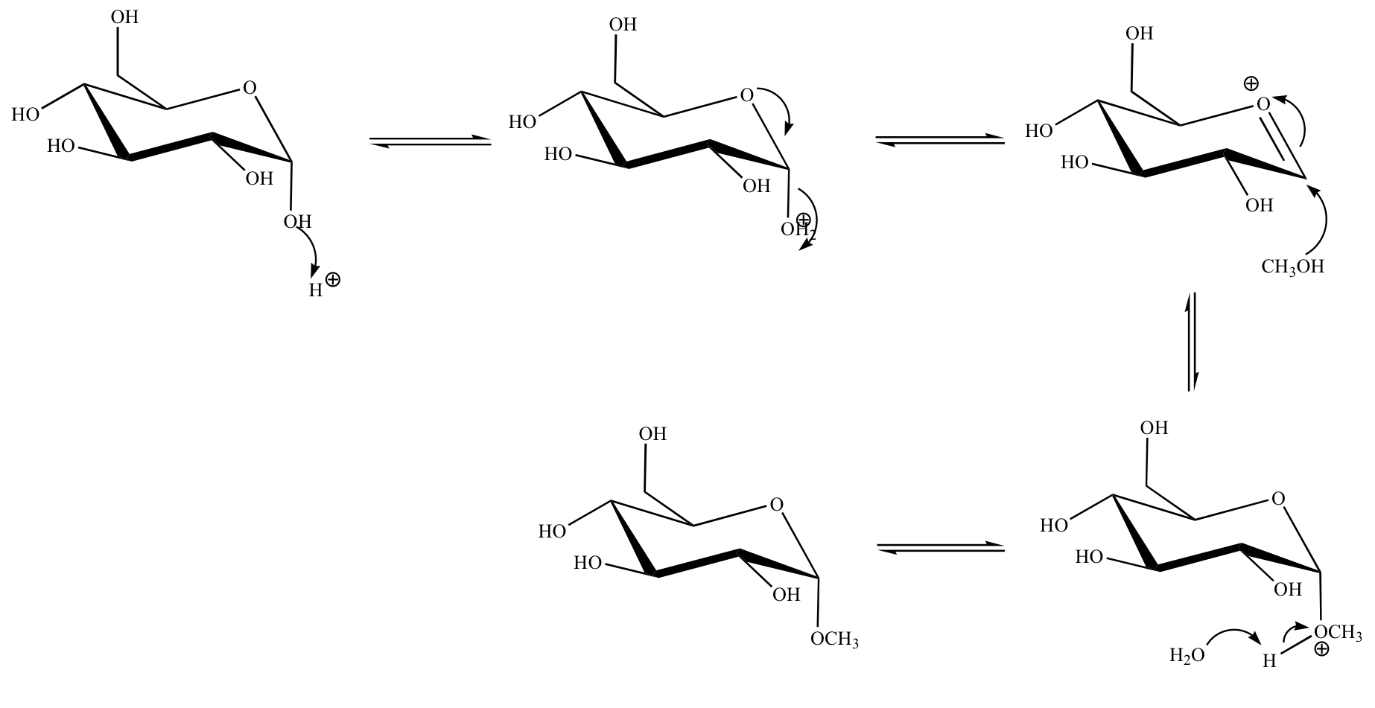

Example 5 - Fructose
Opposite side = alpha
Same side = beta

Example 3 - Table Sugar (Sucrose):
β
α

α−D-Glucopyranosyl-β−D-Fructofuranoside

- Has 2 anomeric carbons
- Non-reducing sugar since it contains an acetal group and does not contain hemiacetals, aldehydes, or alpha-hydroxy ketone
- Can be broken down by the body to glucose and fructose monomer

Monosaccharides – simple sugars such as glucose and fructose – can’t be converted to smaller sugars by chemical reaction (i.e., hydrolysis)

Polymers of Sugars (Polysaccharides)

- Disaccharide: sugars that are composed of 2 monosaccharide units
- Trisaccharide: sugars that are composed of 3 monosaccharide units
- Tetrasaccharide: sugars that are composed of 4 monosaccharide units
- Oligosaccharides: sugars that are composed of 3 to 10 monosaccharide units
- Polysaccharides: long chain of carbohydrates containing more than ten (> 10) monosaccharide monomers.

Cellulose

β-(1→4)-D-Glucopyranoside polymer (Cellulose)

- Cellulose is a polysaccharide composed of D-glucose monomers linked via β-1,4 glycosidic linkages.
- Cellulose is a main component of cotton and paper
- Cellulose is also a raw material for producing cellulose nitrate which is the major component of smokeless powder used as a propellant in ammunition of firearms and artillery.
- β-linkages cannot be digested by most mammals

Starch (Amylose)

α-(1→4)-D-Glucopyranoside polymer (Amylose)

- Amylose (accounts for 20% of the weight of starch) is a polysaccharide composed of D-glucose units linked via α-1,4 glycosidic linkages

Starch (Amylopectin)
→
→

Amylopectin: α-(1→4) and α-(1→6) linked D-glucopyranoside polymer

- Amylopectin is the main component of starch (80% dry weight)
- Amylopectin is characterized by branching via α-(1→6)-glycosidic linkages in approximately every 25 glucose units along the main polymer chain.

Chitin

Other Examples and Information

Reducing Sugars
- Contains either an aldehyde, α-hydroxyketone, or a hemiacetal
- All aldoses are reducing sugars

Non-reducing sugars
- Any sugars that do not contain any of the above functionality (i.e., glycerol) or an acetal group (i.e., sucrose)

Artificial Sweeteners

Sucralose
- Non-reducing sugar

Sodium Cyclamate

Saccharine
Aspartame

