CHEM 261 Nov 23, 2020

**Polyacrylonitrile**

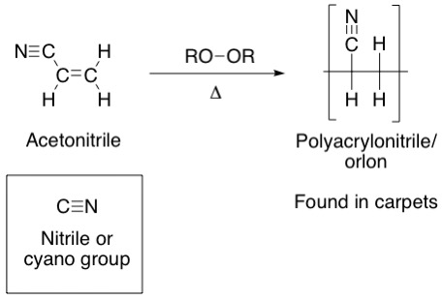

Polyacrylonitrile can form HCN if it is heated to decomposition.

**Polyvinyl chloride**

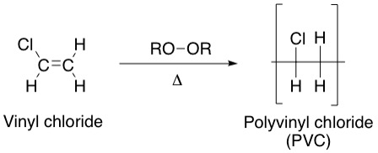

Such polymers containing chloride can form HCl if decomposed.

**Copolymers**

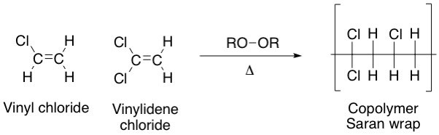

Copolymers are composed of two different subunits.

**Lucite**

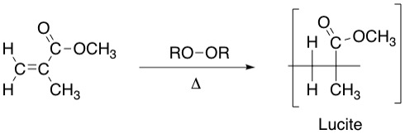

**Polystyrene**

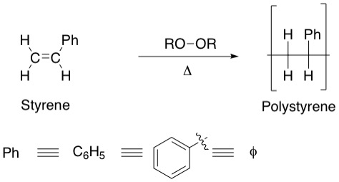phenyl group is Ph

**Example: Mechanism of polystyrene formation**

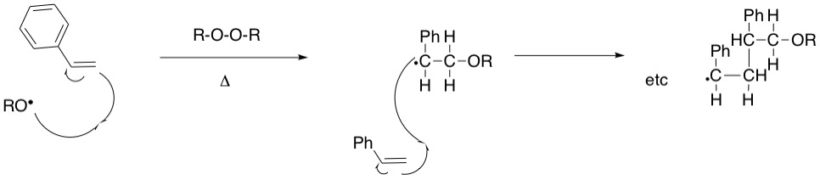

**Short-hand for mechanism of polystyrene formation**

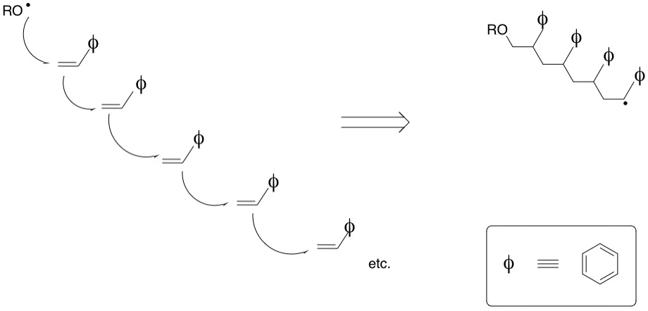

Divinyl benzene can be added as a cross-linker so chains link on both of its double bonds

This make the copolymer more solid (as you encounter in many products) – typically about one part in 100 to one part in 6 of divinylbenzene may be added

