CHEM 261 Nov. 20, 2020

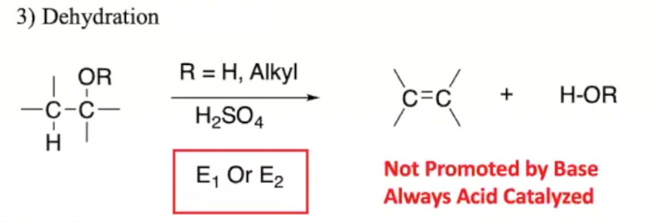

**E1 Reaction:**

- Rate depends on one concentraion

- Not concerted (carbocation intermediate)

- Not stereospecific

- Favoured with leaving group being 3º



**Example #1:**



**Zaitsev Rule:** Get the more substituted alkene

**Example:**



**Example #1:**



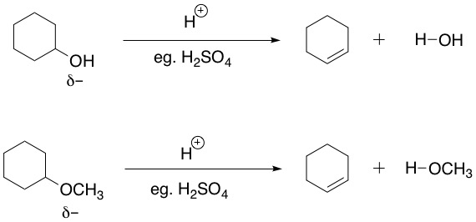

-OH and -OCH3 are bad leaving groups and so these reactions would not occur spontaneously without an acid catalyst.

**Example**



Substitution vs. Elimination:

- Low Temp - High Temp

- Weaker Base - Stronger Base

- Dilute H+ - Conc. H+

- Leaving group on 1º carbon - 2º, 3º

- Small Nucleophile - Large Nucleophile