CHEM 261 November 2, 2020

**Hydroboration**

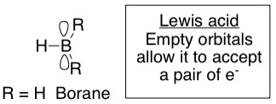

**Structure of borane**

Exists as Diborane (B2H6), but behaves like BH3

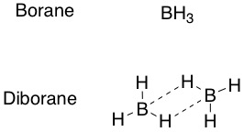

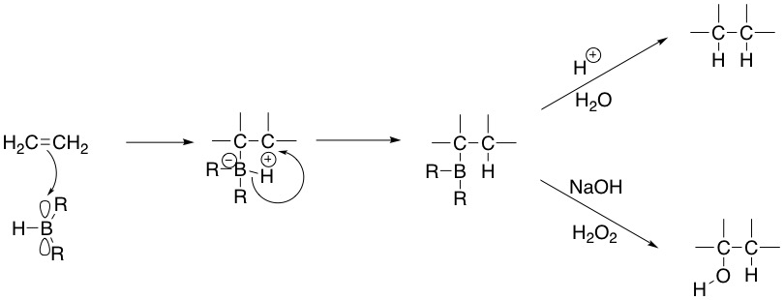

Stereospecific

syn/cis addn.

Cis addition for both reactions

Like H2/ Cat.

(Pd, Pt, Ni, Rh)

**Example**

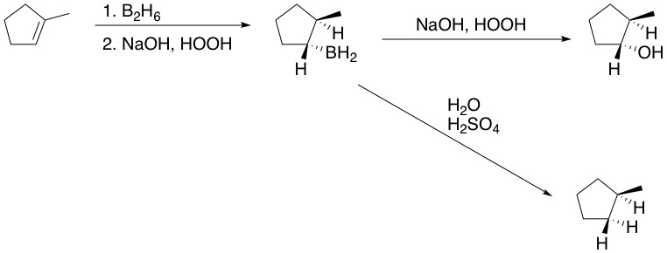

*

*

Syn addition, but anti-Markovnikov add’n of OH