CHEM 261 Dec 2, 2020

Acidity of Alcohols

Name | Structure | pKa | More acidic  Less acidic
methanol | H₃C-OH | 16 | More acidic  Less acidic
ethanol | CH₃-CH₂-OH | 17 | More acidic  Less acidic
isopropyl alcohol |  | 18 | More acidic  Less acidic
tert-butanol |  | 19 | More acidic  Less acidic

There are two alkyl groups attached to the central carbon bearing oxygen in isopropanol. The alkyl groups (methyls) donate electron density to that carbon (an inductive effect) that is already next to a negative charged center (O⁻). Since negative charges repel each other, the anion is less stabilized. Therefore, the anion is even less likely to form (less stabilized than if the alkyl groups (methyls) in isopropanol were missing.

Methanol (pK_{a} 16) is 100 times (10²) more acidic than isopropanol, since it has only hydrogens (a less donating group) attached to the carbon bearing the negative oxygen in the corresponding anion)

For tert-butanol (tert-butyl alcohol), there are three alkyl groups (methyls) that donate electron density to the carbon next to a negative charged group (inductive donation of electrons destabilizes the anion). Therefore, it is less likely to dissociate (pK_{a} 19) and the molecule is even less likely to ionize (less acidic).

Consider the example below:

Where does the equilibrium lie in the above reaction?
Answer: It lies far to the right.

The reaction of a stronger base (isopropoxide) and a stronger acid (water) to a weaker base (sodium hydroxide) and weaker acid (isopropanol) is very fast.

Acidity of alcohols continued …
What is the influence of substituents? inductive & resonance
As the pK_{a} values above show, phenol is 10⁸ more acidic than cyclohexanol.

Phenol has a pK_{a} value of 10 (given this information, you should immediately recognize that it is more much acidic (about 6 orders of magnitude) than water (pK_{a} 15.7) and methanol (pK_{a} 16) since it has lower pK_{a} value). As phenol is more acidic, this means that its conjugate anion is more stable. The phenoxide anion is stabilized through resonance (shown above). It has 4 resonance forms, and therefore, more ability to spread the negative charge and be stabilized.

Where does the equilibrium lie for ionization of phenol to phenoxide and a proton (H⁺) ?

Answer: It lies far to the left (not ionized). Even though phenol is 10⁶ more acidic than water, its pK_{a} of 10 tells you that the acidity constant is 10⁻¹⁰ or that only one part in 10¹⁰ is ionized; the rest exists as phenol with H attached to oxygen.

Example: Chlorophenol

Is the anion more or less stabilized compared to phenol?

Answer: More stabilized. The chlorine atom is electron withdrawing, and stabilizes the negative charge at the para position through the inductive withdrawing effect. However, it also has a weak resonance donating effect. The inductive effect of chlorine wins over resonance effect in this case (contrast this with electrophilic aromatic substitution where the resonance donating effect wins out against the inductive effect).
Example: para- and meta-nitrophenol
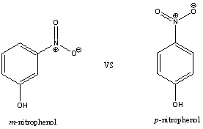
p-nitrophenol has a pK_{a} value of 7.2, whereas m-nitrophenol has a pK_{a} value of 9.3

Which one is more acidic? Answer: p-nitrophenol
Why? (Think about conjugate anion stabilization and resonance forms).

Resonance forms for m-nitrophenoxide anion:
Resonance forms for p-nitrophenoxide anion:

The nitro group offers an additional resonance form for p-nitrophenol that is not possible for m-nitrophenol (we are able to drive electrons all the way in to the nitro group for the para- substituted nitrophenol). Since there is an additional reasonable resonance form, the p-nitrophenol pK_{a} 7.2 is about 100 times (10²) more acidic than the m-nitrophenol with pK_{a} 9.3 (pK_{a} 9.3-7.2 = 2.1 pK_{a} units)
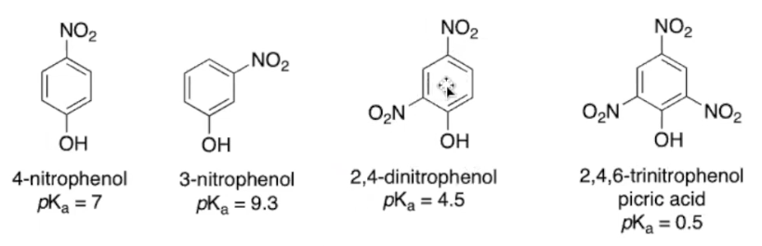

If there are two nitro groups in the ortho and para positions of the phenoxide anion, the pK_{a} of the phenol (2,4-dinitrophenol) drops to 4.5. If three nitro groups are attached, the pK_{a} of the phenol becomes even lower (2,4,6-trinitrophenol has a pK_{a} of approximately 0.5). This is because ortho and para positions are where the negative charge of the resonance form can be located, and addition of a nitro group is able to offer more stabilization. This phenomenon is not observed for the meta position.

