CHEM 261 Nov 16, 2020

**Elimination Reactions:**

2 Types of Mechanisms: E1 and E2



Base vs. Nucleophile:



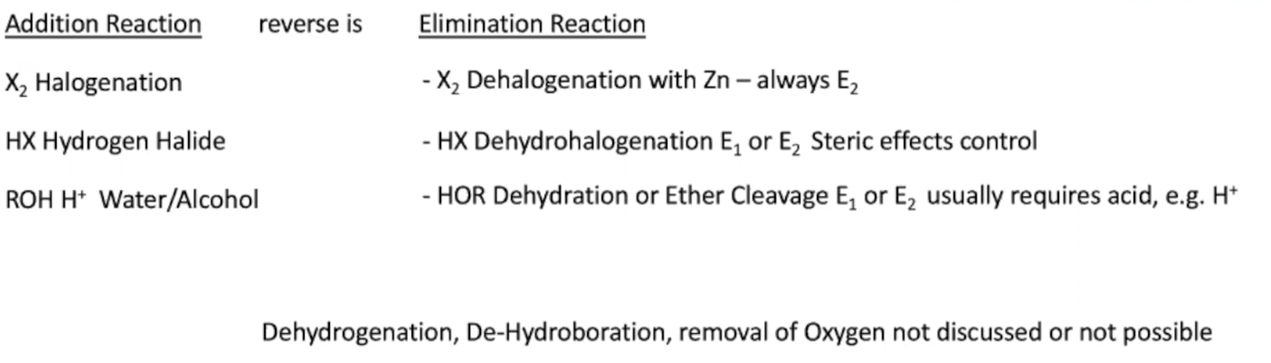

**E2 Reaction** (E=Elimination)**:**

- Rate depends on two concentrations

- Stereospecific

- Concerted (bonds being formed and broken at the same time)

- No intermediate

- Anti-periplanar geometry

1) Dehalogenation



**Example #1:**

**-** Zinc mechanism always proceeds via E2



**Example #2:**



Due to mechanism of Zn, the double

bond is stuck at less substituted end.

Double bond can go to more substituted

if it is left in aced