CHEM 261 Oct 14, 2020

**Chiral Centers:**

***R***



- Carbon stereocenters are shown with dots in this example.

- Nitrogen is a stereocenter here because it can’t invert freely. The ring structure restricts its geometry.

**Configuration at the alcohol center (arrow on quinine):**



**Example: 3-hydroxy-pent-1-ene**



**RECALL:**



Enantiomers have opposite stereochemistry

at **every** stereocenter (chiral center)

Diastereomers are all stereoisomers that are

not enantiomers

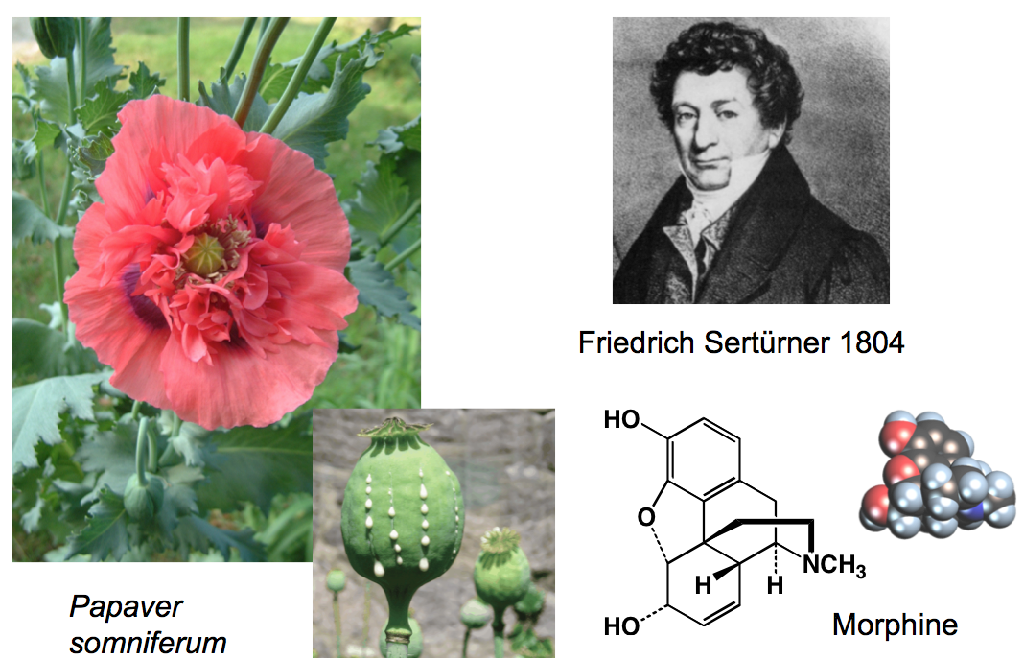

**Morphine:**

* Is an alkaloid, meaning it contains nitrogen, can be isolated from a plant (or bacteria) and is considered a natural product.
* From Morpheus, Greek god of sleep
* Opium: Sap from the seed pod of opium poppy (*Papaver somniferum*)
  + (poppy sleep-carrying)
* ~10% of opium is morphine
* Morphine is used as an analgesic
* Heroin (diacetylmorphine) is even more potent (and more addictive)

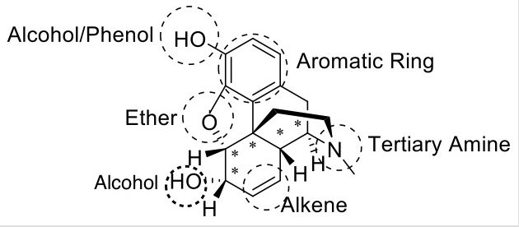

* 5 stereogenic centers in morphine (represented by *)

- 25 = 32 stereoisomers possible, where:

- 1 morphine (itself)

- 1 enantiomer

- 30 diastereoisomers

**Examples of Configuration in Stereocenters of Morphine**

Configuration at the **ether** stereocenter:



Configuration at the **alcohol** stereocenter:



**Pheromones**: from Greek “pherein horman” meaning to carry excitement. Discovered by Adolf Butenanot.

**Male Pheromone:**



Only about 50 % of the population can smell this compound, which is genetically determined. About half find the smell disgusting while the other half find it tolerable or pleasant.

Can be detected by insects at concentrations of 10-17 molar.

Contain 7 stereogenic centers, circled in red above.

What is the R/S configuration of the carbon attached to OH?



**Fischer Projections**

A method of drawing chemical structures, where the horizontal components are coming towards you and the vertical ones are going back.

**Example #1:** Lactic Acid



**Example #2**: Tartaric acid



Meso compounds have stereogenic centers but contain a plane of symmetry and are achiral

Racemic mixtures (or racemate) contain a 1:1 ratio of each enantiomer

**Physical Properties of Enantiomers**

* Same physical properties with achiral agents or procedures
  + Melting point, boiling point, solubility in achiral solvents
* Enantiomers behave differently with chiral agents
* Diastereomers have different physical properties (m.p, b.p, density, solubility)

**Optical Activity**

* Rotation of plane of polarized light
* α = measured rotation (o)
* [α]D = Absolute rotation
  + (+) (clockwise)
  + (-) (counter-clockwise)
* Absolute rotation is 0 o for achiral molecules

**Pure enantiomers show equal but opposite rotation**

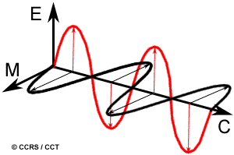

End on view of vector

components of normal light. It is possible to polarize light and remove some of those vectors.

Light has an oscillating electric field (red)

combined with a magnetic field (black)

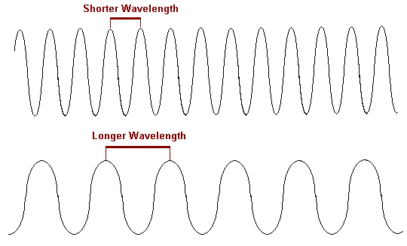

* Longer Wavelength
* Low Energy
* Low Frequency
* Shorter Wavelength
* Higher Energy
* Higher Frequency

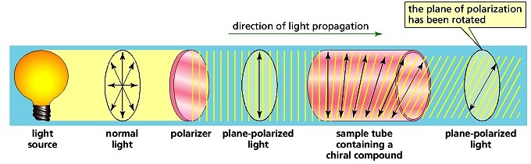

**Optical Rotation**

Factors affecting optical rotation:

* Concentration of compound (c)
* Path length that light travels through the solution (l)

[α]D = Absolute rotation at the D line of sodium (589 nm or 5890 Å)



α = measured rotation (o) c = concentration (g/cm3) l = path length (cm)

D = D-line of sodium light [α] = absolute rotation

Degrees (o) = + : Clockwise

- : Anticlockwise

Example: Carvone

[α]D = - 100 o [α]D = + 100 o



S-carvone (caraway) R-carvone (spearmint)

**Calculating Optical Purity**

For this example for S-carvone, assume the pure S enantiomer has +100o rotation

|  |  |  |  |
| --- | --- | --- | --- |
| **R** | **S** | **Rotation (o)** | **Optical Purity (%)** |

|  |  |  |  |
| --- | --- | --- | --- |
| 100 % | 0 % | -100 o | 100 % |
| 75 % | 25 % | -50 o | 50 % |
| 50 % | 50 % | 0 o | 0 % |
| 25 % | 75 % | +50 o | 50 % |
| 0 % | 100 % | + 100 o | 100 % |

If a solution is an equivalent mix of 1:1 R + S enantiomers, α measured = 0 o

A 50:50 mixture of enantiomers is called a *racemic mixture* (or racemate)

Optical Purity (measured experimentally) = Enantiomeric Excess (ee) (Theoretical value)